# What did you accomplish this week?

Within this week, I was able to accomplish as planned. I was able to complete all instructions that related to the first nibble of the opcode is 4

# How much of the work scheduled was complete, percentage-wise?

Within the second week, I would say 70% of the work scheduled was completed. The remaining percentage was used to implement things that I have not scheduled but will be useful in the long run

# What work was scheduled but not completed

Some of the work was schedule but not complete are:

* Handling with invalid opcode and figure out how do I know when to resume operation
* Printing out immediate data. Currently, can only print out absolute short or long
* Looping until user enter correct address (check valid input)

I would say my implementation is kind of “looking for best case”. Within this week, I will add more to check for invalid data

# How much additional, unscheduled work was accomplished?

Some of the tasks that were not scheduled but I thought of and implemented are:

* Refractor the entire source code by dividing each section. This make the code easier to read and differentiate
* Added utility methods: print screen, query next four nibbles, query the destination mode, destination number, source mode, source number
* Created some jump tables to help with the EA
* Added the ability to convert hex to ASCII

# What poses the greatest risk to your team

The greatest risk that I am worrying now is do not have enough time to do all the operands.

In addition, because of my lack of testing (not really lack of. I just have not really test edge cases), the programs may fail at some places that I am not aware of

|  |  |
| --- | --- |
| TASK | DESCRIPTION |
| NOP | Printed out NOP |
| JSR | Printed out JSR and operands |
| LEA | Printed out LEA and operands |
| RTS | Printed out RTS and operands |
| NEG | Printed out NEG and operands |

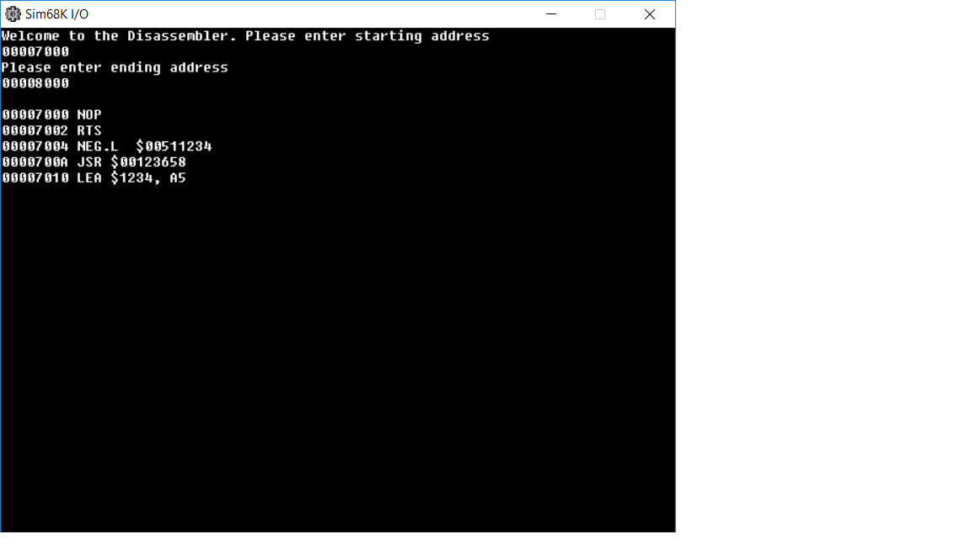Sneak peek at my current progress. Now I catch up with the disassembler, within this weekend, I hope to accomplish at least 3 more types of instructions that start with other nibble